**TCS - STUDENT INTERACTION PROGARM**

On 17th of December 2019, TCS had an Interaction session with the students of II year B.com BPS. Mr. Rajiv Noronha, Vice President & Head HR Analytics & insights group, spoke to the students regarding recent changes in industry. He spoke about the current industrial revolution mainly about Industry 4.0 and Business 4.0. He spoke about Agile, Artificial Intelligence, cloud, automation etc. Students also asked their doubts and they got to know about many aspects of current industrial scenario.

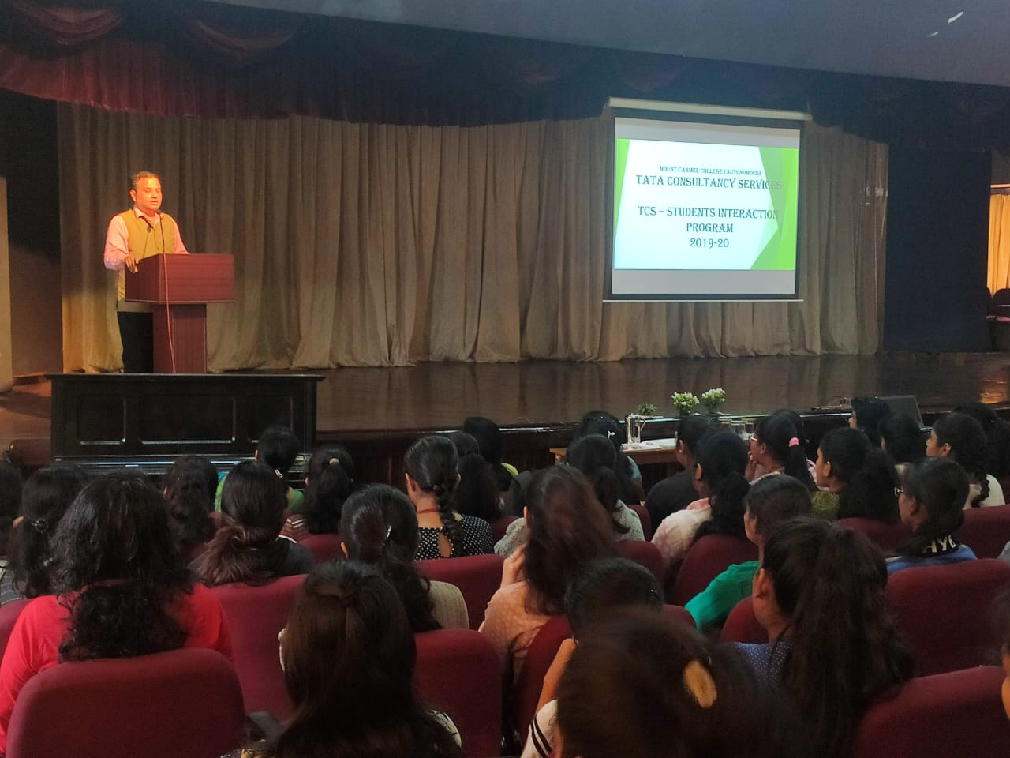

**Mr. Rajiv Noronha interacting with students**

