**PRE-PLACEMENT SESSSION**

A pre-placement session was conducted for the final year students of Mount Carmel College, Autonomous on 29th August, 2019 by Mr. Ravi, Academic relationship manager, TCS who gave them insights about TCS campus interview. It was around an hour session, where he assigned few topics to the students for presenting it on the upcoming pre-placement session. Students were quite delighted with this session as they got to know many things about TCS interview. Next pre-placement session was held on 4th September 2019, where he took presentations of the students to make them get prepared for the interview.

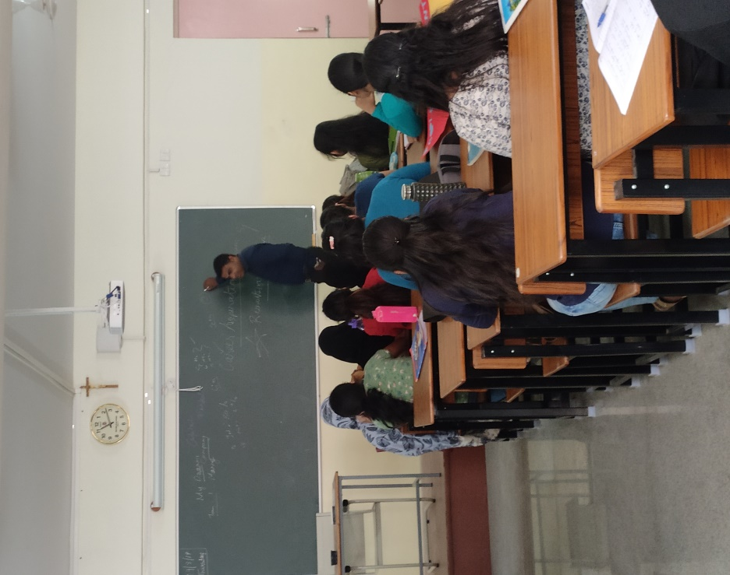

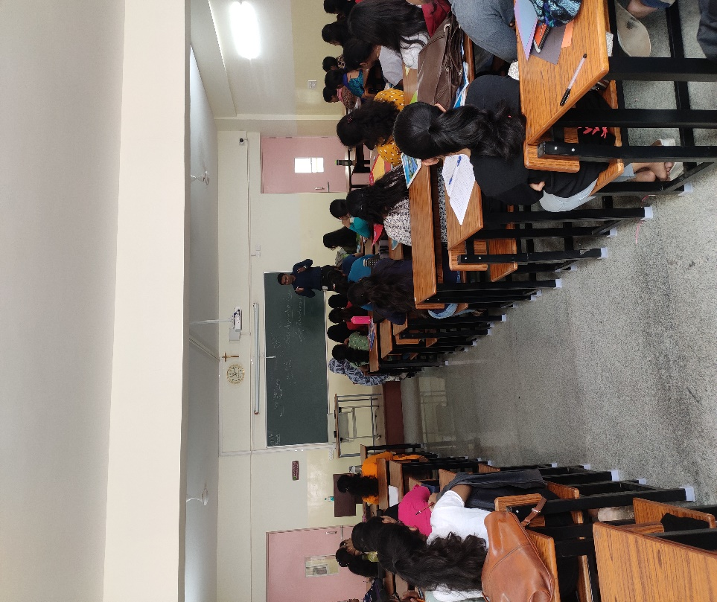

**Mr. Ravi giving insights about placements**