**GUEST LECTURE - BANKING FOR BPS**

A guest lecture was arranged for II year B.Com BPS students on 3rd March 2020 for the subject Banking for BPS. Mr. Anish, Assistant Manager, TCS Banking group, a speaker from TCS spoke about various aspects of banking. Mainly he emphasised on Trade finance. Transactions of International and domestic trade which involves parties, letter of credit and its types etc. It was an hour session in which students got to know about various aspects of trade finance.

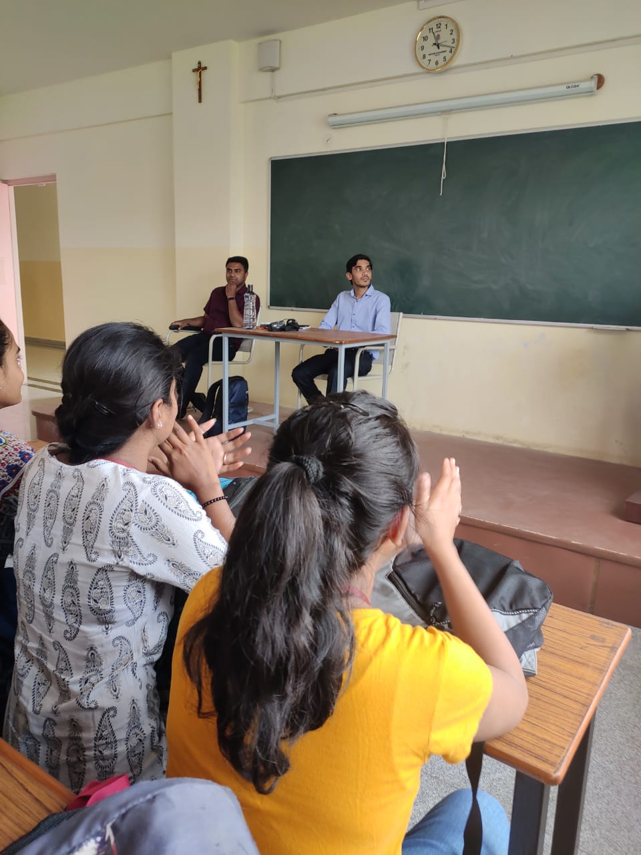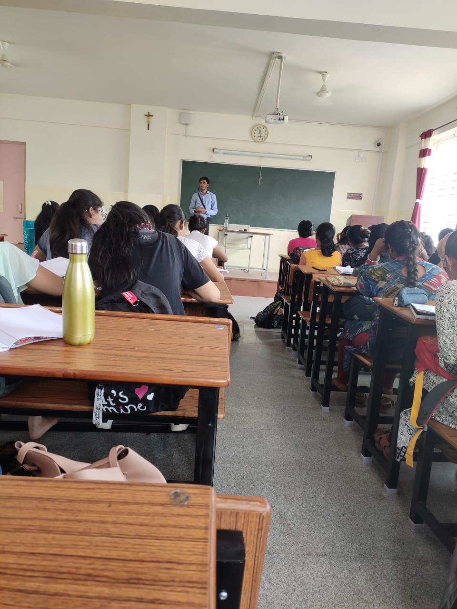**Mr. Anish giving lecture on Trade Finance**