**PG COMMERCE ASSOCIATION OF MOUNTCARMEL COLLEGE, BENGALURU**

**2019-2020**

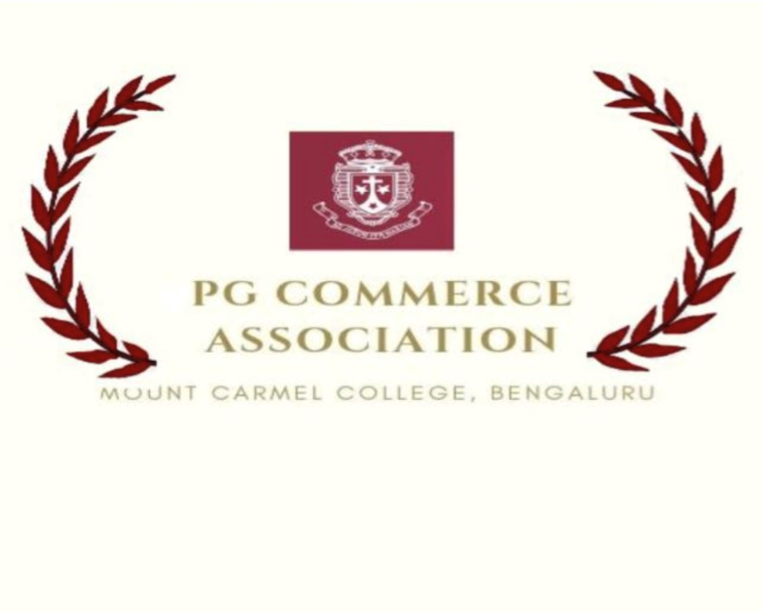

**STUDENT COORDINATORS: SAMPADA SHAH, BABLI KALITA**

**FACULTY COORDINATORS: MRS NITU SHARMA, PROFESSOR SOLOMON JAYKUMAR**

**Guest Lectures:**

**Report on the First Guest Lecture on Competency of Fresher’s and LinkedIn** July 18 2019; The PG Commerce Association conducted the first guest lecture for the 2nd year PG students (Total 110 students) in the MCIM Auditorium.

There were three speakers, Mehar Sheikh, Sonam Raheja and Naz Parveen who have addressed the students on the Competencies recruiters look in Freshers, Challenges faced by the new workforce and Profile Building and Networking. The event was a success and the feedbacks from the students were positive.

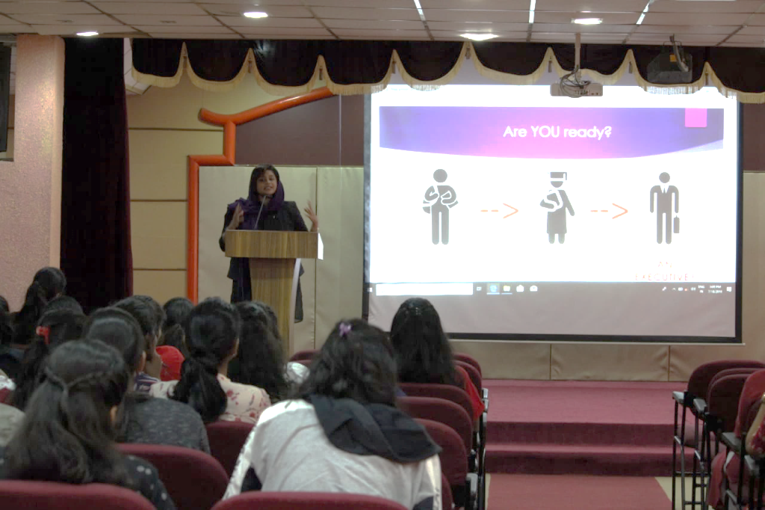

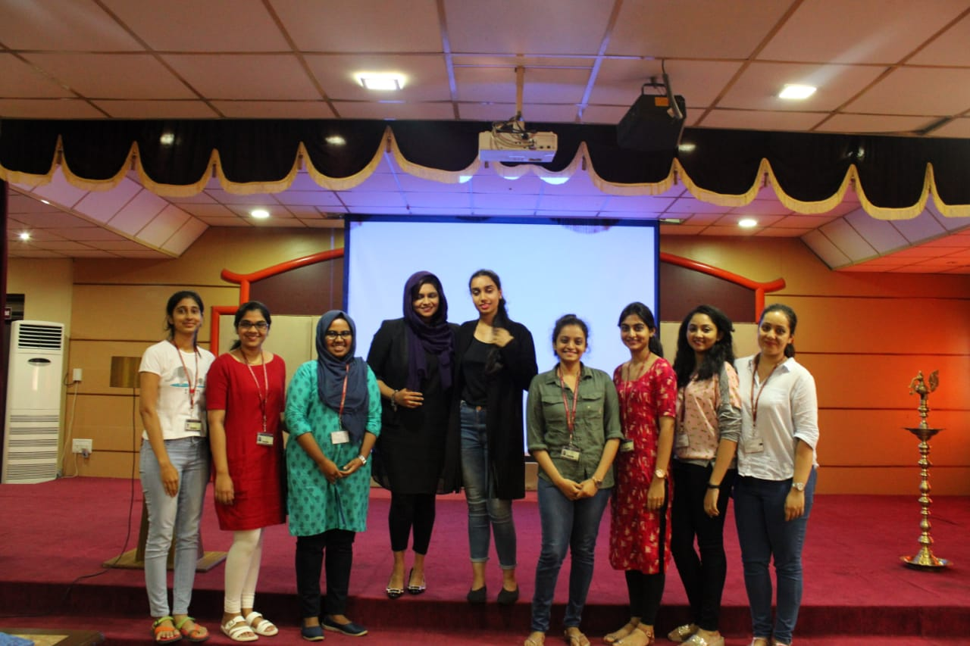

**Second Guest Lecture:**

A Guest lecture Conducted on 17th January 2020 for 1st years M.com and PGDBA students (Total 96 students). Guest lecturer: Naz Parveen (HR Business partner XOXodays, HSR layout)

Miss Naz addressed the first year MCOM and PGDBA students about the organizational culture. The hierarchy level in the organizations, human behavior in a work environment and its impact on job structure, performance, communication, motivation, leadership, etc. The speaker also gave some inputs on 3 levels of the organizational behaviors that is the individual, group and the organization’s entirety.

There are three chief levels that organizationalbehaviors are usually examined. These levels are: the individual, the group, and the organization in its entirety. The individual level focuses on personality, feelings, and motivational effects on how perform on the job.

