One Day Hands-on Training on MS Excel - Report
A One Day Hands-on Training on MS Excel was organized by the IQAC of Mount Carmel College, Autonomous, Bengaluru in association with the Department of Computer Science in order to spread the benefits of MS Excel among the Administrative Staff of the College. The event scheduled on 7th December, 2019 at 10.00 AM in MCA Lab-1, Mount Carmel College, Autonomous, Bengaluru was a successive effort put up by the organizers. The enormous response was well recognized through the participation of around 25 participants. The training was carried out under the guidance of two resource persons Ms. Perpetua F Noronha and Ms Sushma Margaret A, Lecturers from the Department of Computer Science, MCC. The session covered some of the advanced topics like Pivot table, Charts, Arrays and financial formulas.
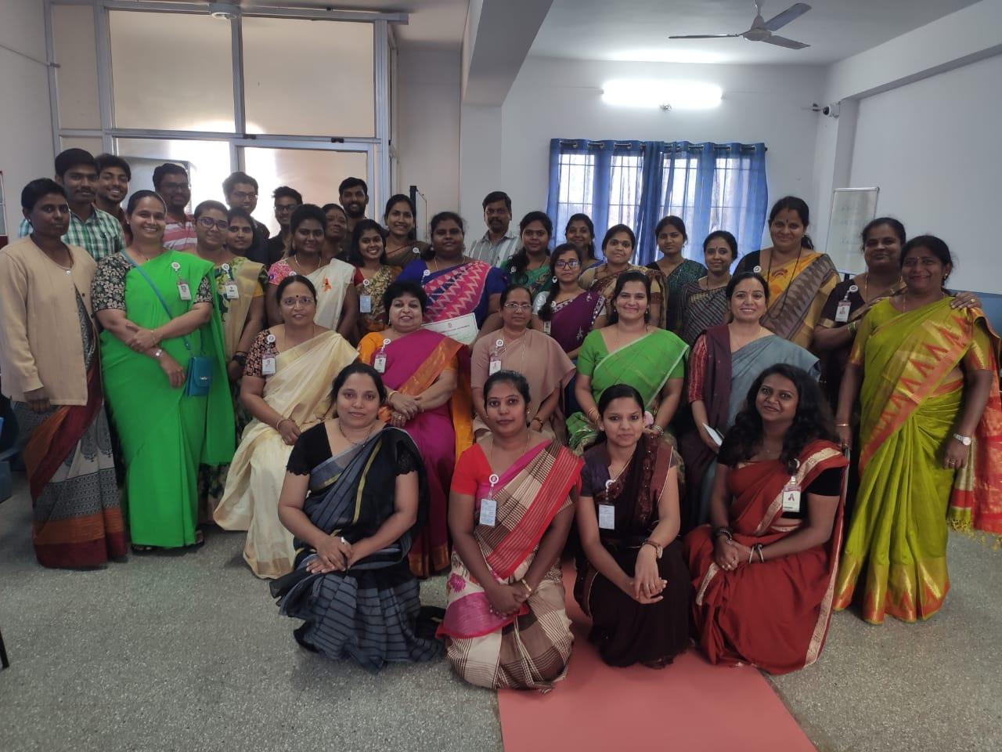

The Session concluded with the distribution of certificates by Principal Dr. Sister Arpana, Vice Principal Dr. Charmaine Jerome in the presence of all IQAC members and Head of the Department of Computer Science Dr. S Regina L Suganthi.

