[](https://mccblr.edu.in/)

**Shades of Inclusion: A talk on Gender Intersectionality in Indian Politics**

**Date: 17/7/2023**

**Venue: GJB001**

**Time:10.00 am to 11:30 am**

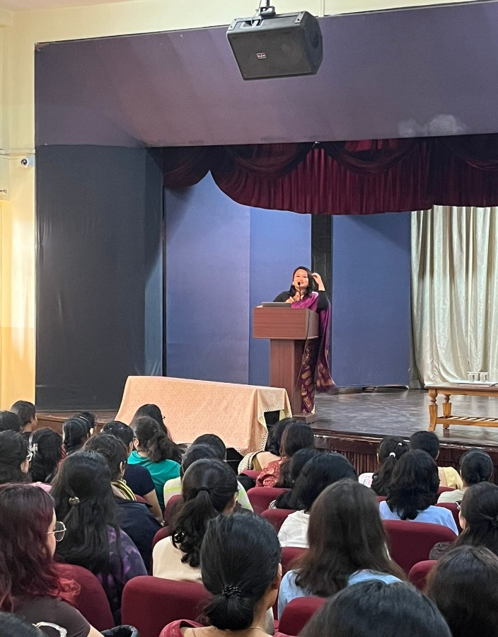

‘Siyaasat’, the Political Science Association at MCC organized an insightful talk with Dr. Tonmoyee Rani Neog. Dr. Neog is not only an assistant professor at Jagannath Barooah College, Assam but also a Feminist Rights activist.

She talked about gender as a social construct and how, through social conditioning, the society has set an unjust binary for the world to follow. The oppression is seen not only among the cis community but is heterogenous for the transgender persons as well. She mentioned how different predetermined aspects of social identity serve no purpose other than to compound oppression.

Ms. Neog also went on to mention the journey and struggles of her friend who is a Queer Activist, Rituparna from Assam. Rituparna has worked exclusively to bring forward problems of the Queer community to the limelight and provide them with a safe space by building a FREE GENDER LIBRARY. The library aims to be a space for discussions and deliberations on the questions of inclusivity.

Ms. Neog also went on to mention the in initiatives started by Rituparna-building gender inclusive toilets in educational institutions. Rituparna is a proud Transgender, non – binary person who loves wearing sarees. On a visit to a university for the social work department, they had to change their clothes but the department only had Men and Women toilets.

It was when Rituparna questioned them that the university decided to have all - gender washrooms to make each community feel more accepted. This started a campaign to build gender neutral washrooms in all public spaces in Assam. Rituparna is now running the “#NoMoreHoldingMyPee” campaign to make educational institutions more inclusive.

Another interesting topic included was how the society gendered certain objects, behaviors and even colors. Dr. Neog condemned this mindset and urged the audience to not fall for these societal traps. A possible reason for the continuation of such practices till date was discussed to be the existing Patriarchy and Capitalism. Both of those benefit from these discriminations as the capitalists earn their profits by introducing concepts like the ‘Pink Tax’ while the patriarchs establish their supremacy.

She also talked about dichotomy in academia where jobs like teaching are associated with women while men take up the decision-making roles. Other forms of discrimination included colorism, the ‘pretty’ privilege, etc. The beauty standards set by the society are imposed generation after generation and are entirely baseless. Overall, the talk proved to be really thought – provoking and gave the audience some much needed insights about gender intersectionality.