[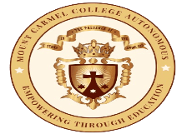](https://mccblr.edu.in/)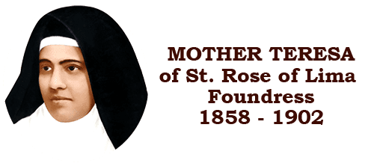

**TALK ON ELECTION ENGINEERING AND TECHNOLOGICAL TRAINING COURSE HELD BY SMART NETA**

**Venue: MTB 106**

**Date: 5/1/2024**

**Time: 10:30 am to 11:30 am**

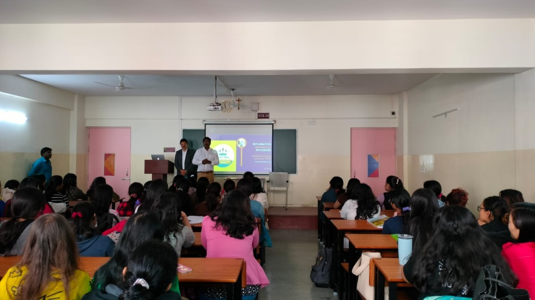

A talk was held by Smart Neta on an election engineering and technological training course offered by them on Friday, 5th January. Smart Neta is a political consultancy firm focused on providing strategic advice with data-driven analysis of political information. The idea is to enable leaders to better understand their constituencies, citizen's needs, and social circumstances. The course will focus upon the use of AI in electoral processes, using location-based specific data to analyse constituencies, etc.

The talk highlighted key aspects of using technology in politics. The use of AI and other technological tools would translate into cheaper campaigns, and make the process more efficient. Data-driven analytical tools provide a clear picture of the people's issues and can lead to good governance. As technological advancements reach new heights, so will the sphere of politics with the help of AI.

The course offered by Smart Neta would provide students with insightful, technical know-how and skill, which is essential in today's modernised workspace. Future career prospects include working with political parties, leaders, political consultancies, working as media analysts and public policy-makers. Other aspects would include understanding electoral aspects from a grassroots level, the use of technology, relevance of canvassing without corruption, all of which enable leaders to focus on people's issues more efficiently.

It would give students of political science the opportunity to practically apply the knowledge of the discipline. In conclusion, the course offered would introduce students to election cycles, data analytics in politics and equip students with practical experience in data collection.