[](https://mccblr.edu.in/)

**Climate Justice 101 with Dhrstadyumn**

**Venue: VC Room**

**Date: 12/10/2023**

**Time: 10:30 am to 12:00 pm**

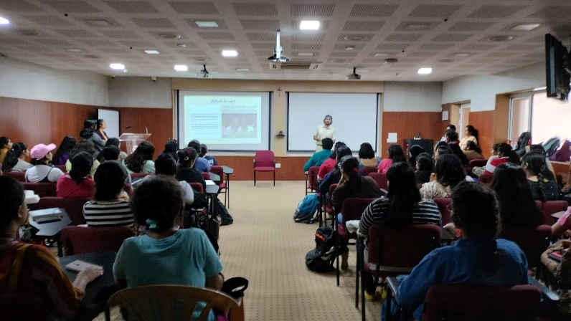

The climate is changing and so should we to hand over the planet safely to the next generation because there is no Earth B. A climate justice talk was held on Thursday, 12th October 2023. The speaker was Mr. Dhrstadyumn, a strong, dedicated enthusiast for environmental protection who is making a difference in the world with his active campaigns and workshops which inspires many citizens across the country  ,who is also the Director of “There is No Earth B” . The session began with an introduction, then proceeded to discuss an article by Fayedsouza on climate change and rise in temperature. The most captivating part was “The Privilege Walk”, which was an activity with 5 volunteers representing 5 different socio-economic backgrounds . We talked about how natural calamities like floods and increases in temperature disproportionately affect their livelihood and state of life in different ways. The talk then shifted to discussing the importance of Climate Justice with reference to developing and developed countries. The meaning of individual Action and Systemic Action was discussed with active participation of the audience throughout the talk delivering their young opinions and ideas. The talk ended with Q&A .

Key takeaways are : a video was shown where youths from across the country gathered and took an initiative to make a difference with climate change in mind, which really enlightened us with the hope and courage that even we can do it . We got to know about Save Sanjay Van, a Delhi environment campaign by TINEB , which was a successful approach a step closer to climate justice by protecting the Reserve forest in Delhi. TINEB is progressing with their climate action approach with 1,80,000 signed petitions from people , clearing 25 tonnes of Non-Biodegradable waste , 12,000+ volunteers, online events ,cleanup events and many more on the way. We learnt how, even with a small step, we can make an impact and inspire others to join hands for Climate Action as it rightly goes : “There Is No Earth B”