**MOUNT CARMEL COLLEGE, AUTONOMOUS**

**DEPARTMENT OF BUSINESS STUDIES**

**WEBINAR ON INTELLECTUAL PROPERTY RIGHTS**

**TITLE: IPR**

**DATE: 11 SEPT 2021**

**PLATFORM: MS TEAMS**

**AUDIENCE: FINAL YEAR BBA STUDENTS**

**RESOURCE PERSON: VIVEK ANAND SAGAR**

The objective of the session is to enhance the knowledge of students on IPR and also to bring about awareness on the IPR laws in the country.

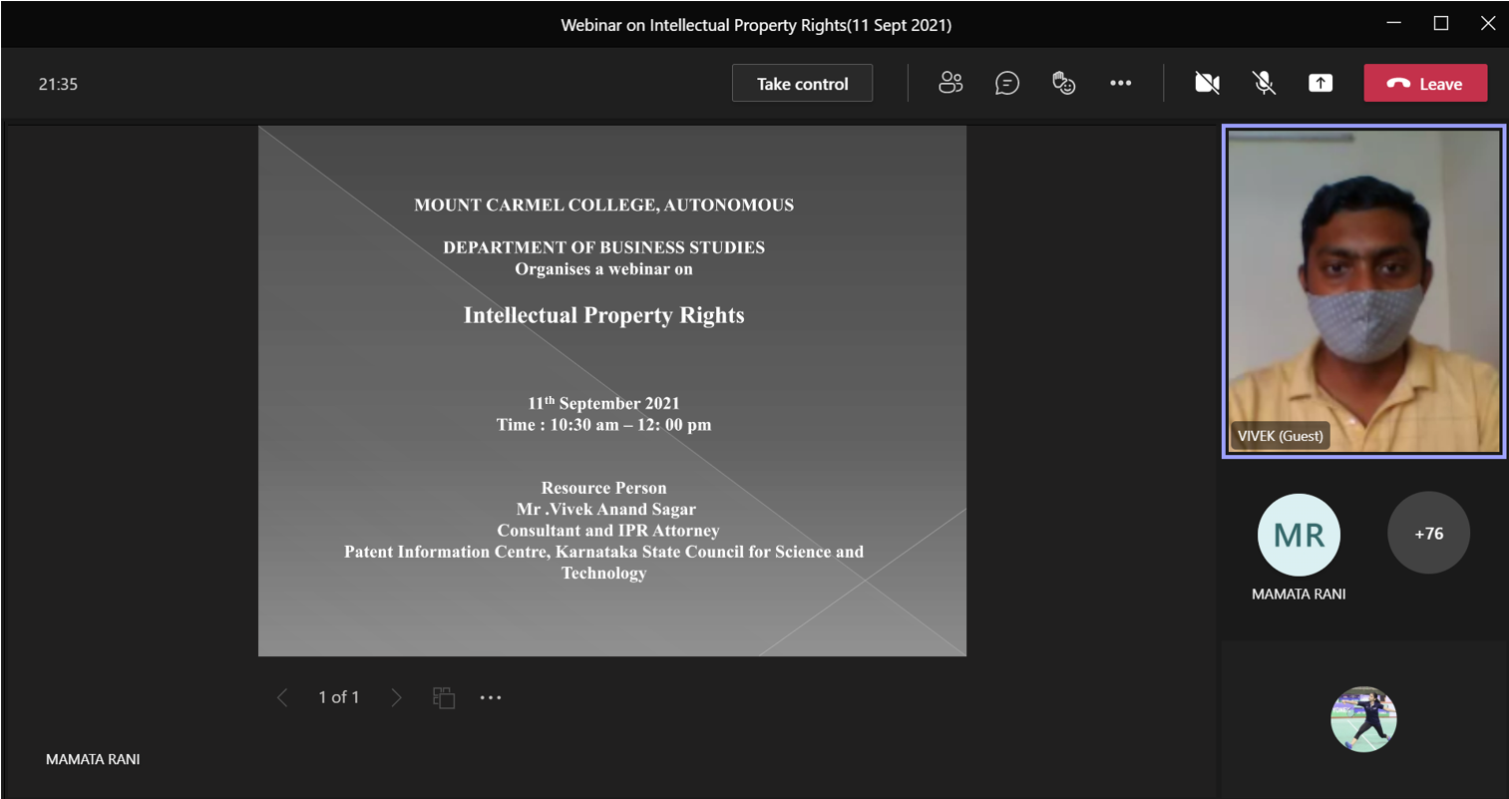

Followed by the introduction given by Mamtha Ma’am and then Krithika M (Student from BBA A).

Sir conducted a very interactive session and ensured we understood the concepts discussed by asking questions throughout and we could type answers in the chat box.

Topics covered during the session were:

1. How can products be patented? With a few examples. (Mrs. Ramya Bose- 10th std Student from Kerala who made mechanism similar to washing machine and earned recognition for her successful work)
2. How innovation has become necessary during the pandemic.
3. Discussed a few utilization strategies that can be adopted:
4. Secure
5. Share
6. Explore
7. Transfer
8. Venture
9. Collaborate.
10. He shared a few statistics with regard to the trends in patent for the last 5 years.

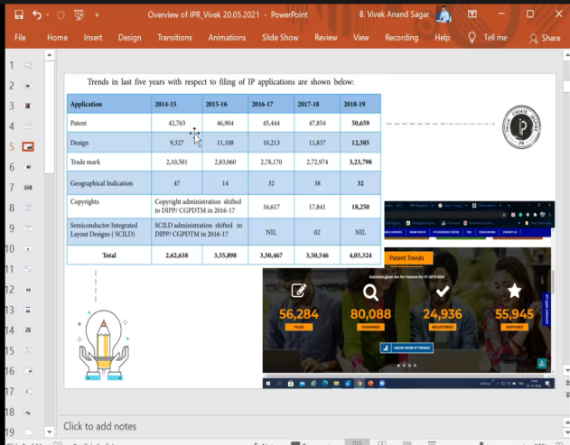

1. The necessity to register for patents, It’s importance and its usefulness.

A patent Registration will help protect the invention and the intellectual property from being used by others, it grants credit only to the owners. Others will require your permission in order to use it with the Govt. of India.

1. How Patent applications are received throughout the world.

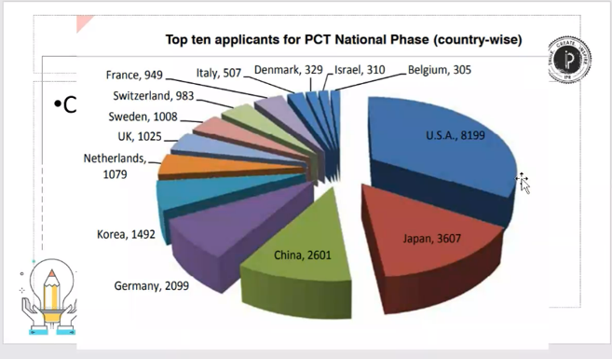

1. How innovation is the key to be a market leader.
2. Exclusive definition of Patent.

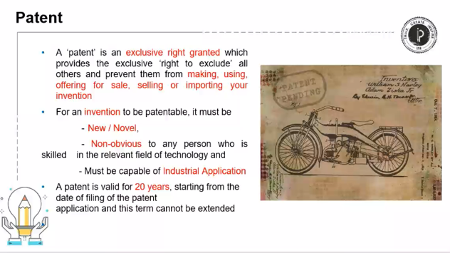

1. Distinguishing between patentable and non patentable inventions.

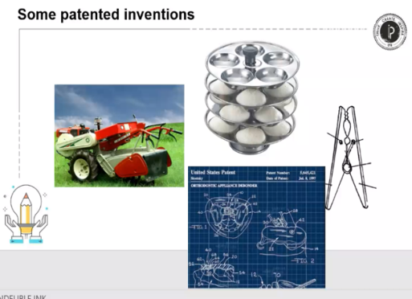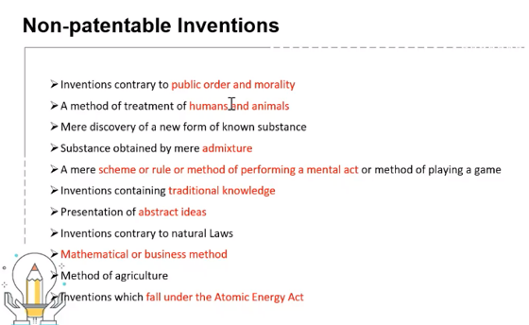

1. The detailed procedure to get Patent Rights.

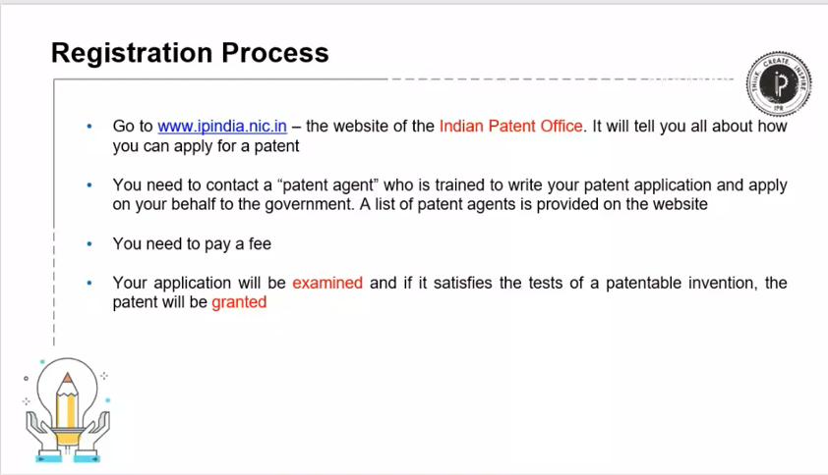

1. A specimen copy of how a patent application looks like.

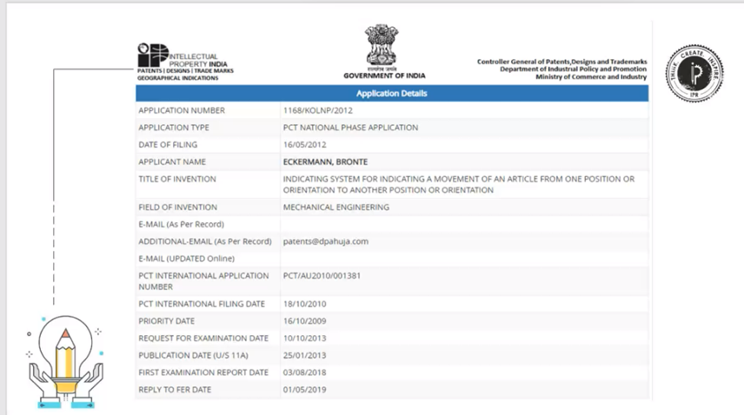

1. The various types of Intellectual Property rights.

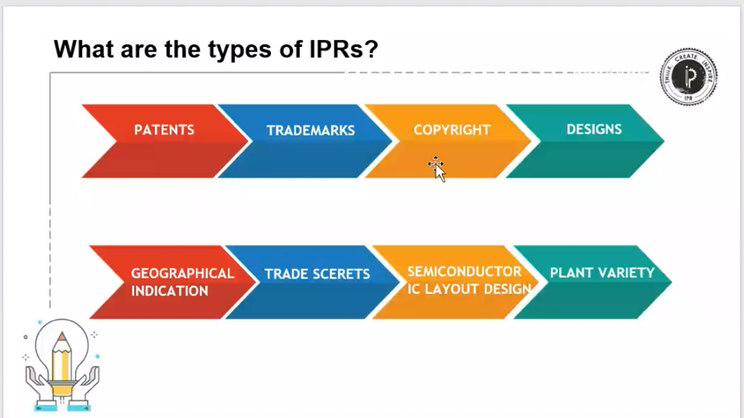

1. What are trademarks? How is that significant?

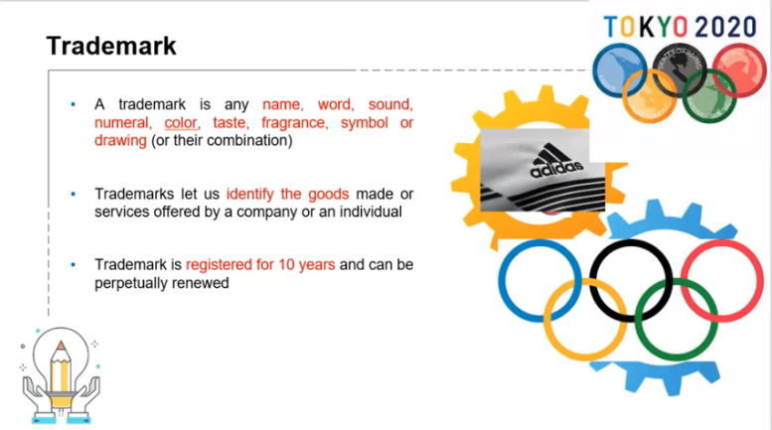

1. How can we, as Individuals contribute to IP?
2. Be innovative
3. Don’t purchase fake products/ encourage them
4. Think outside the box
5. Produce Original work
6. How is patent different from trademark?

Patents are different from trademark. They have their own benefits & both must be acquired wherever possible. There is one thing that makes it common is that the owners enjoy their exclusive rights and makes it illegal for others to copy or use them. Patents are used mainly to protect the ideas of the innovators and reduces the malpractice of duplicating while Trademark protects the goodwill along with the logo/ symbol associated with it.

1. A few cases when patent rights cannot be availed.

Main reason being services and unfortunately, it cannot be patented. Examples: Ola, Uber, Amazon.

The session was thoroughly enjoyed by us, since sir kept giving live examples and kept asking our opinions and feedback for the questions posed.

Vote of Thanks was given by Preeti (Student of BBA B).

Special thanks to **Mamtha Ma’am** for conducting this session, it was very insightful and we got an opportunity to interact with the IPR Attorney from the Karnataka State Council.