[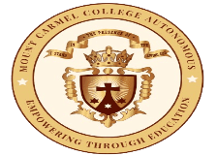](https://mccblr.edu.in/)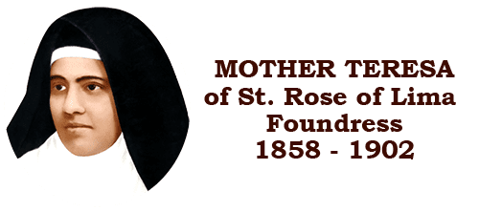

**Seminar on Education Bengaluru (Brand Bengaluru)**

**Venue:Town Hall,Bengaluru**

**Date:15/09/2023**

**Time:10:00 am -2:30 pm**

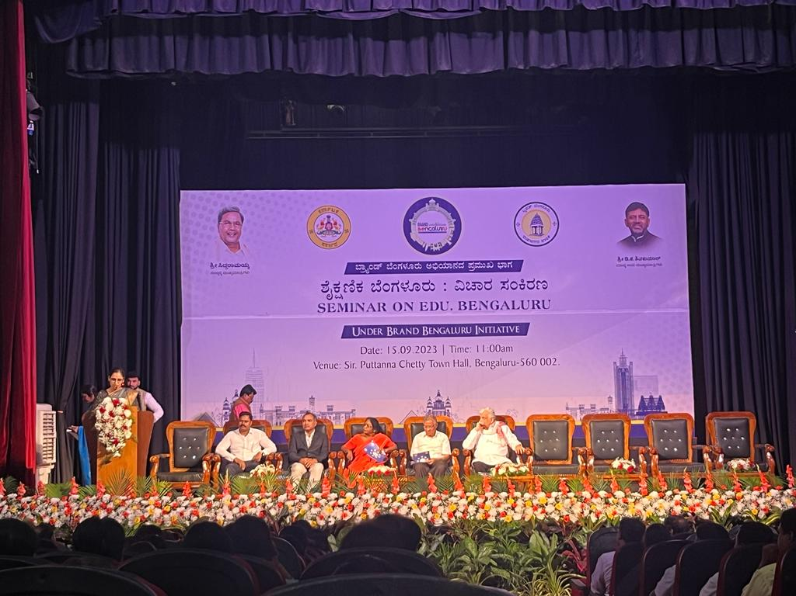

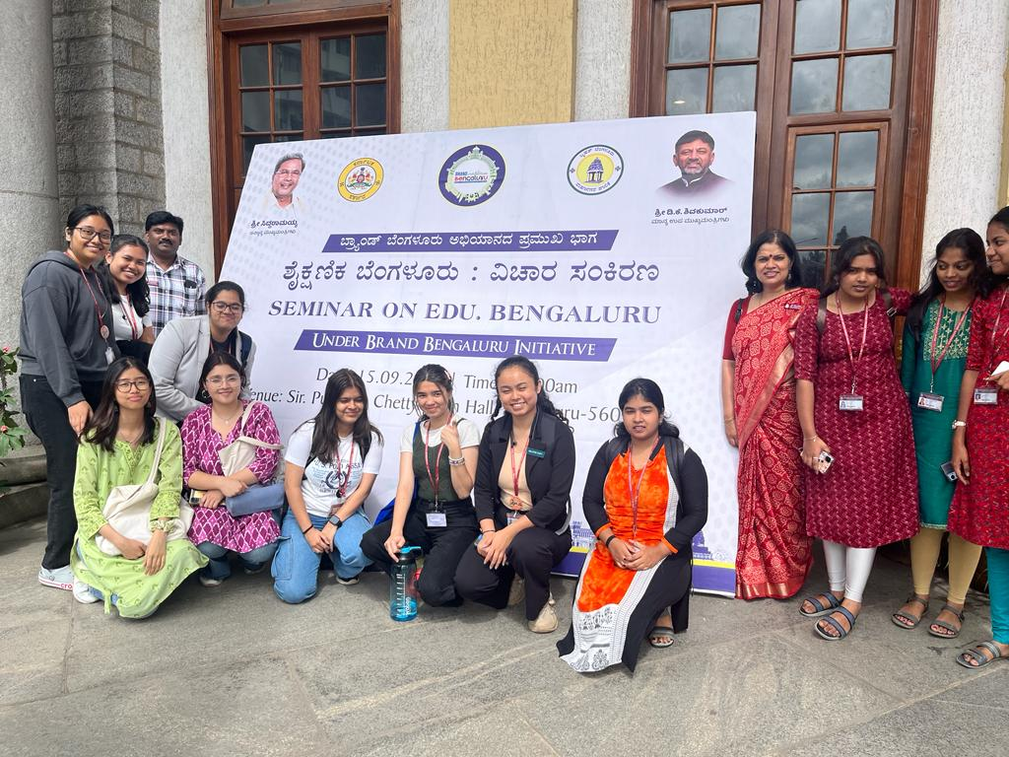

Department of Political Science attended a Brand Bangalore initiative seminar on Education Bengaluru on 15th September 2023 .Speakers were Former Vice Chancellor Dr Venugopal, Dr. Ramakrishnan and IAS Preeti (Special Commissioner) Issues discussed : Alumni strengthening ,Basic education made free ,Teacher's training is needed before implementing new schemes ,Hybrid teaching to be resumed ,Get funds for the institution, One child one tree to save environment ,No closed classrooms it should be supported by smart classroom.

It was a very informative talk on various subjects relating to government education and state education policy. It was an open discussion among the speakers, professors, and student who were seated in the audience. They wanted our feedback on the education system and how can they improve the government schools. Giving them the same opportunity as private schools. They also gave the government the idea of digital library.