**WEBINAR REPORT**

**Topic :** Emerging Trends in Finance Domain

**Audience:** Final year Bcom students (General)

**Total no. of Participants:** 107 students

**Organised by:** Dr. Josephine Rebecca, Ms. Chaithra & Ms. Sitara

**Date:** 16th February 2021

**Duration:** 1 Hour 20 Mins

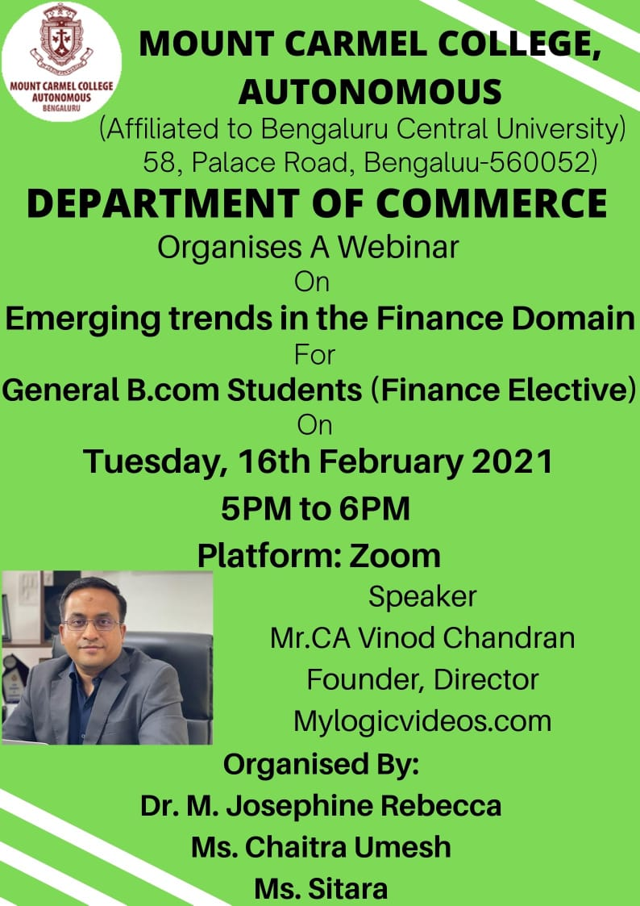

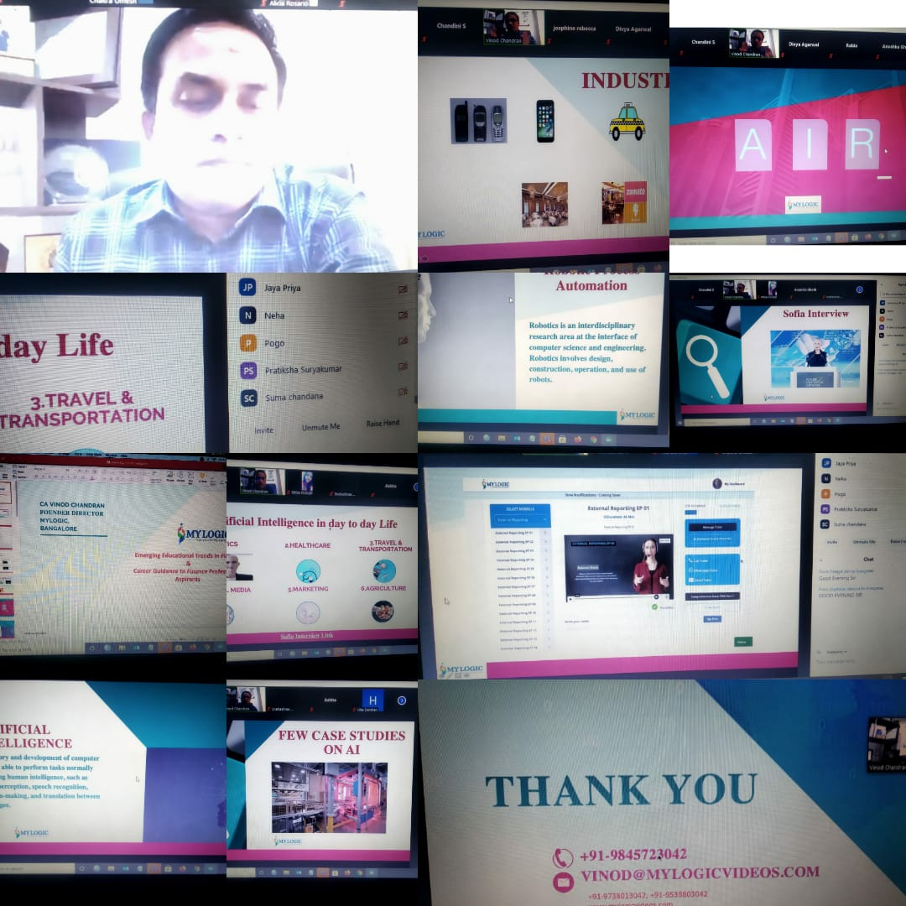  
**Overview and Topic of Discussion:**

**Mr.Vinod Chandran** opened the webinar by providing the overview of the 4thIndustrial Revolution indicating how the changes happened in the industries over a period time. He gave us the complete insights on the transition and advances in Aritificial Intelligence, Robotics and Internet of Things. By using the key word AIR the speaker tried to relate the theory and development of computer systems which is able to perfor tasks normally which requires human intelligence such as visual perception, speech recognition, decision making and translation between languages which basically signifies Aritificial Intelligence(A). The speaker also spoke about the scripting software Sophia Interview which analyses conversation and extracts data that allows it to improve responses in the future and explained about Artifical intelligence in day to day life which his used in all the prominent sectors of the industry like health care, transportation, social media, marketing, agriculture etc. To make sure that the students are attentive the speaker used various videos and case studies relating the live examples which was happening in the industry.

Sir also described about Internet of Things(I) which helps the interconnection via the internet of computing devices attached in everyday objects, enabling them to send and receive data by using examples activity trackers, location tackers, smart cars, voice assistants.

Sir also highted Robotic Process Automation(R) which is a technology that allows anyone to configure computer software or a robot to intergrate the actions of human interaction with digital systems to excecute business process.

He helped us to visualise the impact of AI in Finance industry, grasp the changes in the finance process and the segments being transformed by AI

The speaker also focused on the career development programmes in the finance domain. He also briefed about ACCA, CMA USA, CPA, CIPA, CIMA, CFA, and various other advanced financial courses and discussed about how my logic videos can be a massive advantage in building a profession for the students.

Overall the session was very informative and had a lot of key takeaways which was very much essential for the final year students in order to plan their career effectively.