[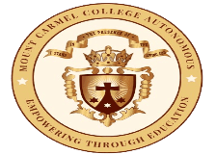](https://mccblr.edu.in/)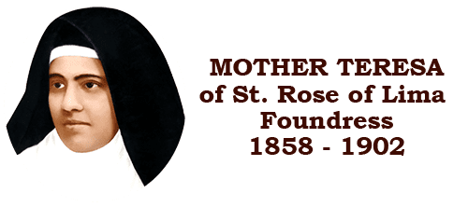

**Workshop on careers in Public Policy and International Relations**

**Venue: LSCB Seminar Hall**

**Date: 22/09/2023**

**Time: 10:30 am to 12:30 pm**

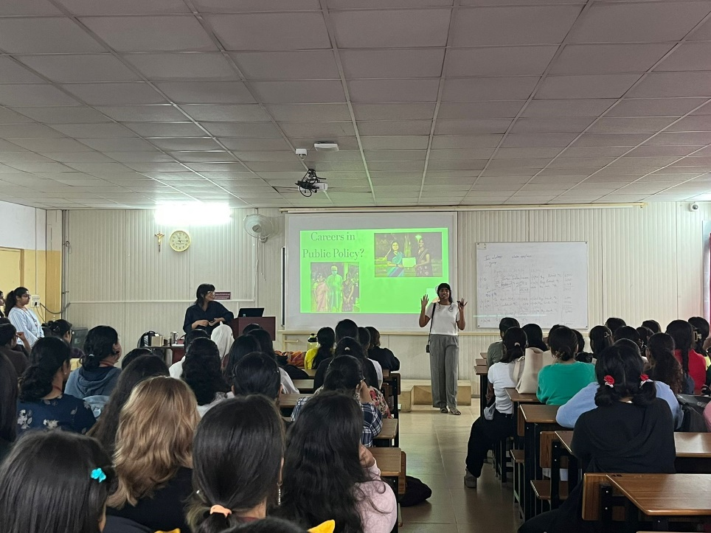

A workshop on career paths in public policy and international relations was held on Friday, 22nd September. The speakers were alumni of MCC and provided meaningful insights in terms of basic requirements, general advice and possible career trajectories in political science. With respect to careers in public policy, research opportunities, consultancy, working with governments and social development are the most relevant pathways. With respect to IR, the most relevant domains are those of research, consultancy and social development.

A few takeaways - the relevance of pertinent industry-specific experience, through fellowships and internships with governments, NGOs, think tanks (with ORF, The Takshashila Institution, Gateway House) as well as the significance of Master’s degrees for certain trajectories, relevance of networking, importance of skills in data analysis and statistics, as well as cultivating a reading habit. Also, relevant information in terms of critically assessing one's choices pertaining to further studies was discussed. The workshop provided students with the opportunity to interact with seniors in a conducive environment, gaining advice in terms of navigating one’s future, reiterating the fact that it is not too late to begin planning and working towards one’s career goals.